STOP/INTREPID Teleconference: Wednesday, November 5, 2025 @ 1-2 PM EST.
General meeting link

Next Teleconference: Wednesday, December 3rd, 2025 @ 1-2 PM EST

Teleconference Summary (details below)
- NEW! Health Infobase Page - Tobacco Control Directorate announced the launch of a new resource: Tobacco and Vaping Use in Canada.
- STOP Portal Updates – Combat 2.0, reminders about STOP/CAMH affiliation, and discussion of STOP follow-ups.
- STOP Portal Discussion – Discuss usefulness of training videos on various Portal functions (e.g., generating reports, inventory tracking/adjustments).
- STOP Drop-in Session – Optional 1hr session hosted monthly by STOP team for operational support.

Land Acknowledgment:
- Identify the land you are joining us from today (https://www.whose.land/en/)

NEW! Tobacco Control Directorate launches updated Health Infobase page
- The Tobacco and Vaping Use in Canada page features:
  - Interactive data on tobacco, smoking, and vaping use among people in Canada
  - Detailed breakdowns by gender, age group, province, etc.
  - The option to display the data as either prevalence rates or population estimates
- Data was taken from the 2023 Canadian Community Health Survey for adults (18 years and older) and from the 2019 and 2023 Canadian Health Survey on Children and Youth (12 to 17 years old)

STOP Portal Updates

Combat 2.0
- In the upcoming weeks, we will be launching a direct-to-patient digital brief Intervention for alcohol reduction that will be available only to patients who self-enroll. We will send out advance communication via email prior to launch.

What can patients expect when they self-enroll?
When patients complete their STOP baseline survey through self-enrollment, those who report higher levels of alcohol use (AUDIT-C score of 8 or above) will see:
- an automated alert message in the portal that encourages awareness and reflection
- the option to download/receive via email a ‘Steps Towards Safe Drinking’ Guide with evidence-based tips for making change.
Patients with higher AUDIT-C scores (10 or above) will also receive extra guidance about reducing alcohol use safely.

Will this affect your (STOP practitioner) day-to-day operations?
We do not anticipate any major changes to your day-to-day.
- This digital brief intervention will appear only during a patient’s self-enrollment survey and will not show up in surveys for patients enrolling directly with you. On a patient’s self-enrollment survey you will be able to see if the patient was shown the automated alert message with the recommendations for reducing alcohol use (it will appear below the alcohol questions; See Figure 1 below for an example).
- Patients who receive the digital intervention may bring up their alcohol use during their visits with you.

Figure 1: Example of what will show on a patient’s self-enrollment survey.
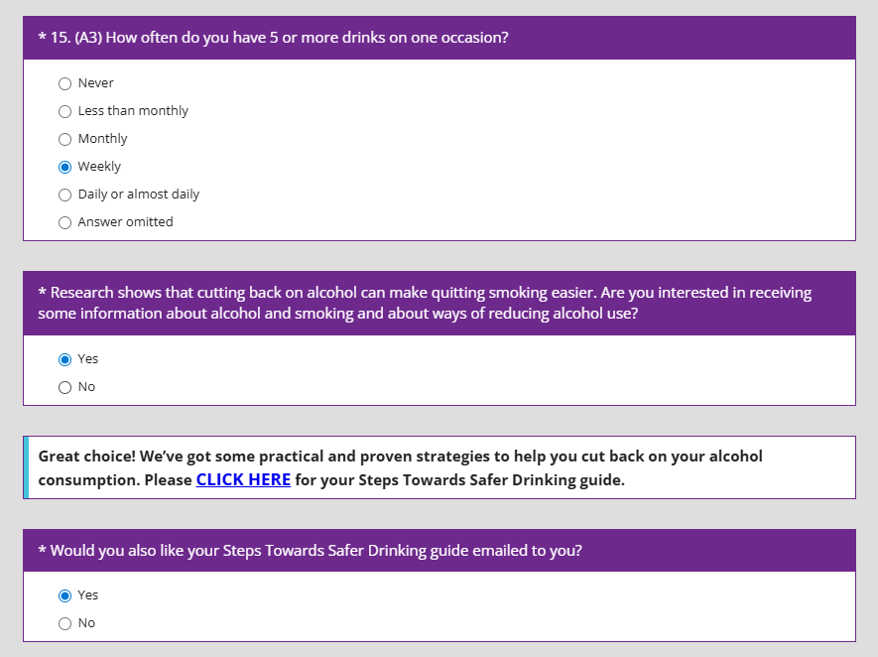

When will COMBAT 2.0 launch?
We anticipate it launching within the next 2 weeks. We will send out advance communication prior to launch.

Combat 2.0 Q&A:

Q: Are these resources available for all STOP clients and/or practitioners?
A: For now, these resources are only available to clients who self-enroll and opt in to receiving said resources.

Q: Can practitioners see whether or not their self-enrolled clients requested the resource?
A: Yes, this will be visible on the completed Registration and Baseline. Reminder: clients enrolling with the clinic (not self-enroll) will not see Combat 2.0 resources at all.

Q: Will STOP add self-monitoring tools for cannabis use as well?
A: The focus is on alcohol right now, but this feedback is good for future iterations. For now, practitioners can use the following: Canada's Lower-Risk Cannabis Use Guidelines.

STOP Program Follow-Ups
- To ensure our follow-up completion rates remain consistent, we ask that practitioners emphasize the STOP Program’s affiliation with CAMH and let clients know that 6- and 12-month follow-up calls will be completed by CAMH staff and that the caller ID will show “Centre for Addiction and Mental Health” when they call.
- We also asked: As practitioners, how do you engage with clients? How effective is the 12-month follow-up for re-engaging with clients/getting clients to re-enroll in the program?
  - Some practitioners are able to touch base with their patients at 12 months to discuss their potential re-enrollment if they are still smoking. There has been success by some to re-engage patients in their treatment.
  - Some practitioners try to implement frequent check-ins, but lack of time and workload can be a barrier.
  - Some practitioners have more success re-engaging with patients at 6 months, citing that those not engaged at 12 months were less likely to be active in the program

Q: As some practitioners mentioned pulling the list of patients due for a follow-up survey, others asked how to access the follow-up list on the STOP Portal?
A: On the dashboard, click Patient / Client then View follow-ups. The follow-up list can be filtered by site, follow-up type, expiry date, etc. You can also turn on email notifications for weekly follow-up summaries (click Administration, then User notifications, then check off Daily or Weekly next to Follow-up summary).

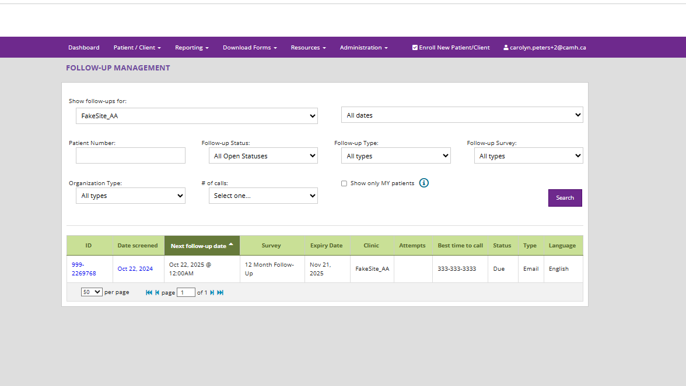

Let’s Chat – Training Videos for Practitioners

Would training videos for different STOP Portal functions (e.g., generating reports, inventory adjustments) be helpful? Should they be added to the Portal, our website, etc.?

- Practitioners agree that training/tooltip videos would be helpful, especially for non-daily/infrequent tasks (e.g., inventory adjustments, generating reports, re-enrolling clients)
- Please connect with the STOP team and provide any additional insight/feedback you have!

Q&A:

Q: Are we able to update the Baseline form on the Portal after it’s already been saved/completed?
A: Yes. Please email your respective organizational inbox (e.g., stop.fhts@camh.ca). STOP staff will unlock the form so you can enter new/additional information.

Q: How do we engage with clients who have memory issues?
A: STOP asked Dr. Peter Selby and his recommendation was to have the client use their own techniques for reminders, such as written reminders, alarms on the phone, etc. He also suggests that the practitioner consider the fire risk for the client.
A: The INTREPID Lab YouTube channel (TEACH Project) has an archived TEACH Educational Rounds specific to Tobacco Interventions for Clients Living with an Acquired Brain Injury. Please click here to watch.

News:

Smokers’ Helpline launches the Milestone Contest
- To mark the their 25th Anniversary, Canadian Cancer Society’s Smokers’ Helpline has designed this initiative to celebrate the diverse and meaningful steps individuals take on their journey toward becoming or remaining tobacco- and vape-free
- Participants at any stage of their quit journey are welcome!
- Contest Details
  - Who Can Enter: Residents of Ontario, Manitoba, Saskatchewan, Prince Edward Island, and Yukon who are the age of majority and are current or former tobacco users
  - How to Enter: Participants can submit their milestone entry online or by calling:
    - PEI, MB, SK, YK: 1-877-513-5333
    - ON: 1-866-641-7675
- Prizes: 50 cash prizes of $100 will be awarded—25 in each of the two contest periods:
  - Period 1: November 1 to December 31, 2025
  - Period 2: January 1 to February 28, 2026

NEW! Youth Vaping Survey from LungNSPEI
Eligible Participants
- Youth ages 16 to 24 years old
- Must be vaping or have recently quit
- Survey completion makes you eligible to win one of ten $100 gift cards!

Survey available here: https://www.lungnspei.ca/vapingsurvey

WHO tobacco trends report: 1 in 5 adults still addicted to tobacco
- Though the number of tobacco users has dropped (1.38 billion in 2000 to 1.2 billion in 2024), tobacco still hooks one in five adults worldwide
- WHO has also estimated global e-cigarette use for the first time and more than 100 million people worldwide are now vaping, including:
  - Adults: at least 86 million users, mostly in high-income countries
  - Adolescents: at least 15 million children (13–15 years) already using e-cigarettes
- WHO is urging governments to step up tobacco control and fight back against tobacco companies that are constantly adapting and developing new, targeted products for adults and youth alike

New study shows integrated collaborative care helps youth access mental health and substance use supports faster
- The YouthCan IMPACT project was the first randomized clinical trial worldwide to compare an integrated youth services (IYS) model with traditional hospital outpatient adolescent psychiatry services
- While youth in both groups experienced meaningful improvements in mental health and functioning, those in the integrated collaborative care team (ICCT) group began services within nine days on average, compared to 27 days for the hospital group, and required fewer psychiatric resources
- This provides strong support for integrated care and potentially demonstrates significant cost savings to the health system
  - Read the paper here: Integrated Collaborative Care for Youths With Mental Health and Substance Use Challenges: A Randomized Clinical Trial)

STOP Drop-in Support Session

The STOP Team will host a 1hr support session monthly for practitioners needing assistance with the STOP Portal or other operational issues.

Next session: Wednesday, November 19th from 10 a.m. to 11 a.m.
Click here for link to join

Anyone is welcome and no question too small to answer!

2025 teleconference schedule:

​January 8*  *Changed due to New Year’s Day | ​February 5 | ​March 5 | ​April 2
​May 7 | ​June 4 | ​July 2 | ​August 6
​September 3 | ​October 1 | ​November 5 | ​December 3

STOP on the Net participant quote:

“Just wanted to say that this has been incredibly helpful for me in cutting back and eventually quitting nicotine. It's going really well, and this service is exactly what I needed. I've also referred a couple of friends to the program, and I hope that they'll sign up soon!”

Attendance:
Access Alliance CHC
Algonquin FHT
Almaguin Highlands FHT
Anishnawbe Muskiki AHAC
Arnprior and District FHT
Athens District FHT
Bancroft FHT
Banwell Gardens
Black Creek CHC
Blue Sky FHT
Carepoint CHC
Carlo Fidani RCC
Central Brampton FHT
Chatham-Kent PHU
CHIRS
City of Lakes FHT
City of Kawartha Lakes FHT
CMHA Algoma
CMHA Durham
CMHA Peel
ConnectWell CHC
De dwa da dehs nyes AHAC
Dufferin Area FHT
Durham Regional Health
Elmgrove Living Centre
Estrie CHC
Four Villages CHC
Georgian Bay FHT
Golden Manor LTC
Good Shepherd Homes
Grandview Medical Centre
Great Northern FHT
Group Health Centre
Guelph FHT
Haldimand FHT
Halton ADAPT
Hamilton FHT
Happy Valley FHT
Health for All FHT
Homewood Health
Indwell Community Homes
Kingston CHC
Kirkland District FHT
Leeds and Grenville FHT
Listowel Wingham FHT
London FHT
London InterCHC
Lower Outaouais FHT
Maitland Valley FHT
Manitoulin Central FHT
Mino Bimaadsawin
Napanee Area CHC
Niagara North FHT
Niagara Region LTC
North Bay NPLC
North Cochrane AA
North Durham FHT
North Lambton CHC
Owen Sound FHT
PAARC AA
Queen’s FHT
Queen Square FHT
Rama First Nations
Regent Park CHC
Scarborough A FHT
Seaway Valley CHC
Smithville FHT
South East PHU
Stratford FHT
Summerville FHT
Sunnybrook Hospital
St Michael’s Homes
Temagami FHT
The Neighbourhood Group
Thunder Bay PHU
Twin Bridges NPLC
Univi Health Centre
Upper Canada FHT
Upper Grand FHT
Vaughan CHC
Vitanova Foundation
Wabano AHAC
Waterloo Regional Health
Wellington Terrace LTC
West Elgin CHC
Windsor RCC

